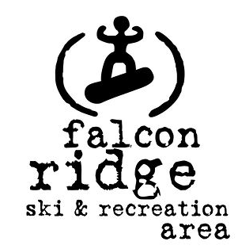

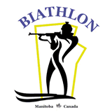

Race Notice: The Falcon Combined Jan. 28th and Jan. 29th 2017
A two-day competition of Nordic Skiing and Biathlon hosted by Red River Nordic Ski and Biathlon Club
at Falcon Ridge
Registration Deadline: Wed. Jan. 25th at 12 midnight on Zone 4
https://zone4.ca/register.asp?id=14596&lan=1&cartlevel=1

Day 1: Saturday, January 28th 2017
CCSAM Provincial Sprint Championships Manitoba Cup Race #4
+ Biathlon Manitoba Biathlon Open House/Open Range
Contacts:
- Chief of Competition Chris Roe roechristopher1967@gmail.com
- Competition Secretary Ron Pelletier skinnyskis@me.com

Technique: Free (no classic tracks will be set)
Sprint Format: King’s Court*. Sprint Qualifier + 3 Heats.

- Each skier competes in an interval qualifying time trial to determine placing in the first heat.
- There are six athletes in each heat and a total of three heats following the time trial.
- In the heats, the top two finishers will move down the bracket into a faster heat.
- The bottom two finishers will move up and the two middle finishers will stay in the same (heat) position.
- All heats in the 800 m and 1.1 km courses are coed.
- Placement in the final heat (3rd heat) will determine podium finishes according to CCSAM competitive age group categories.

- Wed., Jan. 25th @ 12:00 midnight | Registration closes on Zone 4
- Fri., Jan. 27th @ 12:00 midnight | Official Race Lists posted on Zone 4
- Sat., Jan. 28th @ 9:30 am | Bib pick up in the Falcon Ridge Chalet and all courses open for pre-skiing
- Sat., Jan. 28th @ 10:00 am | Coaches’ meeting in the Falcon Ridge Wax Hut
- Sat., Jan. 28th @ 11:00 am | Sprint Qualifiers
- Sat., Jan. 28th TBD | Sprint Heats
- Sat., Jan. 28th @ 2:00 pm | Awards in the Falcon Ridge Chalet
- Sat., Jan. 28th @ 2:30 pm | Biathlon Open House at the Biathlon Range  Come experience Biathlon shooting. Ages 11 +

CCSAM Competitive Age Categories
Your competitive age category is based on how old you are as of December 31st in the current competitive season. For example, your age as of December 31, 2016 is your age for the entire 2016 – 2017 competitive season. Our Competition Model makes it possible for young skiers to compete in categories that are a better match for their development age if not their chronological age. For example, a Midget aged skier may race as a Juvenile whenever the athlete, their parents and coach together determine that to be the most appropriate competitive category. Skiers wanting to race in a category other than their competitive age category must notify Ron Pelletier, the competition secretary by e-mail by Jan. 26th at 10pm.
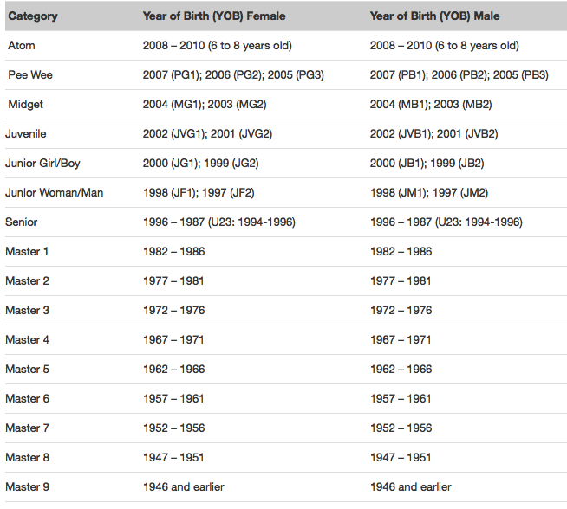
Race Distances & Course/Elevation Maps:

Sat., Jan. 28th 2017  Free Technique Distances Interval Start (15 sec.)  Biathlon Start Area |  | Sprint Qualifier @ 11:00 am  Sprint Heats TBD
Category | Distance (km) | Course

Midget Boys | 800 m | Purple
Midget Girls | 800 m
Pee Wee Boys | 800 m
Pee Wee Girls | 800 m

Masters, Senior, Junior Men + Junior Boys + Juvenile Boys | 1.1 km | Green
Masters, Senior, Junior Women + Junior Girls + Juvenile Girls | 1.1 km
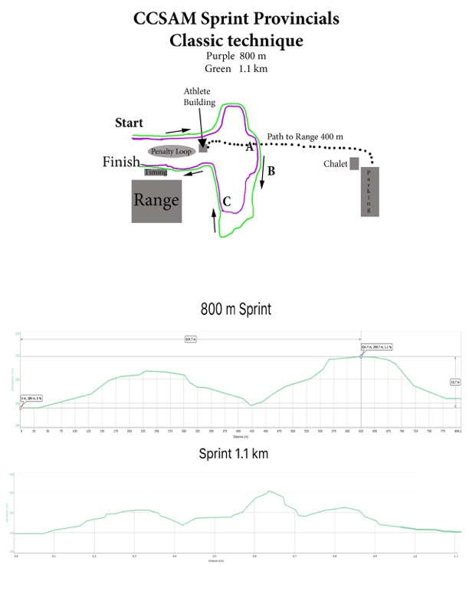

Eligibility: All competitors in Juvenile and older categories must have a valid CCC race license or hold a CCC supporting member (day license) in accordance with CCC Document 2.2.2 – Race License Policy. Day Licenses are to be purchased on the Zone 4 registration page for a fee of $5.00/day.
Day 2: Sunday, January 29th 2017
Biathlon Manitoba Cup Race #2 @ 12 noon
Format: Sprint
Hosts: Hosted by Biathlon Manitoba
Contacts:
- Chief of Competition Lin-P’ing Choo-Smith choosmith@gmail.com
- Competition Secretary Ron Pelletier skinnyskis@me.com
- Chief of Course Kenton Frith kf.frith@gmail.com
- Chief of Range Barry Mitchell bgmitchell@shaw.ca

SPRINT Race: See table for race distances.
- Two shooting bouts, missed targets elicit a penalty loop
- Shorter course, biggest targets & rifle rest for developmental (Dev) athletes
- Youth and adult/masters categories. For Athletes 11+ this is your opportunity to participate in a biathlon race in the developmental categories.
Technique: Free

- Wed., Jan. 25th @ 12:00 midnight | Registration closes on Zone 4
- Fri., Jan. 27th @ 12:00 midnight | Official Race Lists posted on Zone 4
- Sun., Jan. 29th @ 10:00 am -10:45 am | Bib pick up in the Falcon Ridge Chalet
- Sun., Jan. 29th @ 10:00 am – 10:15 am | Coaches’ meeting in the Falcon Ridge Chalet
- Sun., Jan. 29th @ 11:00 am – 11:45 am | Rifle Zeroing (ammunition provided for Dev athletes)  Course open for pre-skiing (Athletes are not permitted on the course until Chief of Course has officially announced that the course is open for pre-ski.)
- Sun., Jan. 29th @ 12 noon | Races begin
- Sun., Jan. 29th @ 2:30 pm or upon race conc. | Awards in the Falcon Ridge Chalet

Biathlon Race Distances: Course Maps: link
- Distances and courses are subject to change due to conditions.
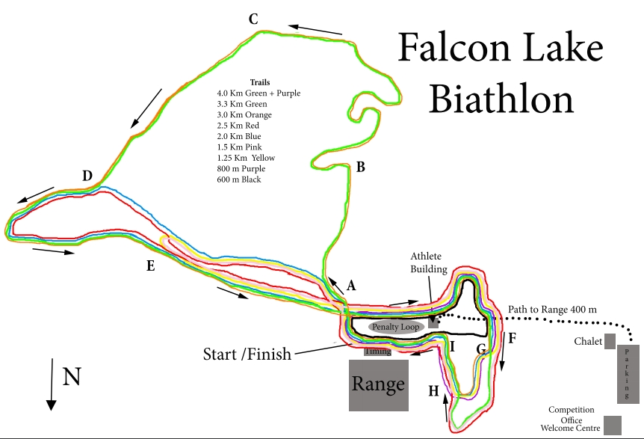
Eligibility: All competitors must be a member of a Biathlon Canada club or purchase a ‘Day Licence’ on the Falcon Combined Zone 4 registration page.

Location: Falcon Ridge Ski and Recreation Area. Falcon Ridge link
Located on the shores of Falcon Lake in the Manitoba’s Whiteshell Provincial Park, Falcon Ridge offers beautiful views of the lake amidst a woodland Boreal Forest setting. Falcon Ridge has over 25 km of maintained x-country ski trails connecting to the local Trans-Canada trail, and Provincial Park maintained West Hawk ski trail circuit which has endless kilometers of wilderness to explore. There are trails groomed for both classic (track set) and skate skiing.

Driving Directions: How to get to the Falcon Ridge Ski Area. Google Map link
Falcon Ridge Ski Hill is located on the south-east end of Falcon Lake in the Whiteshell Provincial Park in Manitoba.
To get there, turn off the #1 highway at Falcon Lake, about 7 minutes west of the Manitoba/ Ontario border. Once
you've turned off the highway, follow the south shore road (past the golf course, the lumber yard and the marina) for
about 15 minutes. Falcon Ridge is located right at the end of this road. Falcon Ridge is a 90 minute drive east from
Winnipeg, and 45 minutes west of Kenora, Ontario.

Accommodations: Falcon Ridge Resorts located in Falcon Ridge. There are numerous accommodations in Kenora.

First Aid: Courtesy of the Canadian Nordic Ski Patrol.

Participant Fees:
- One-day fee for participants 18 and under: $15
- One-day fee for participants 19 and up: $20

- Two-day fee for participants 18 and under: $25
- Two-day fee for participants 19 and up: $30

Refunds: Refunds are determined by the race committees on a case by case basis.

